BUSINESS PLAN

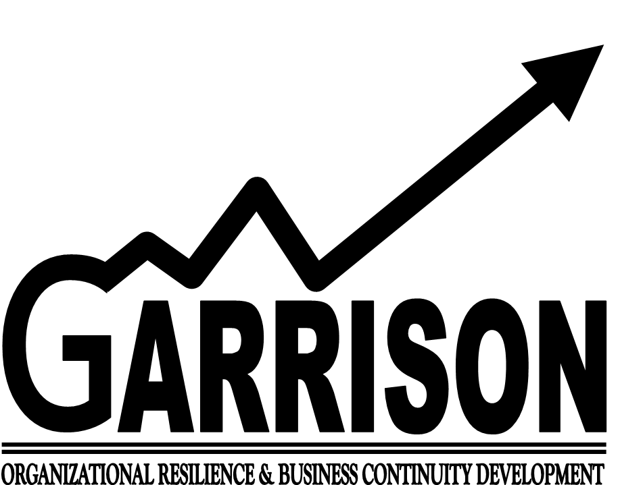

OWNERS

Garrison Business Systems, LLC
113 W. Front St.
Adrian, MI 49221
Tel: (517) 264-7233
Fax: (517) 264-7234
E-mail: inquiries@amisafe.com

Executive Summary

Company Summary
A comprehensive disaster recovery/business continuity implementation is critical to maintaining operations, safeguarding employees and property, mitigating the risks and vulnerabilities, and remaining compliant with federal, state, and local law before, during, and after catastrophic events. Quite often, challenged with the constraints of the current trend in lean operations, companies lack the core competencies required to assess and develop infrastructure resiliency, produce and implement disaster recovery/business continuity plans, conduct pre-incident training, and/or certify their disaster recovery/business continuity programs.

Newly formed Garrison Business Systems, LLC, comprised of disaster recovery and business operations experts, steps forward to help companies in the human and public services sector with pre-disaster planning and certification.

Vision Statement
We will contribute toward and protect a healthy economy and high quality of life for all by helping our clients build the world’s best disaster-resilient business systems and processes.

Mission Statement
We will protect our clients’ prosperity in the face of adversity by providing the most ethical, qualified and effective disaster prevention and preparedness document preparation and audit services available to the human and public services sector.

Table of Contents
BUSINESS PLAN 1
I. Executive Summary ii
Company Summary ii
Vision Statement ii
Mission Statement ii
II. Table of Contents iii
III. Business 1
General Description of Business 1
Services 1
Contingency Audit 1
New Program Development 2
Certification 2
Testing, Drills, Practice, and Training 2
Management and Organization 3
Organization Structure 3
Team Charters 7
Implementation Team Charter 7
Consulting Sub-Team Charter 9
Research & Development Sub-Team Charter 12
Marketing Sub-Team Charter 14
Human Resources Sub-Team Charter 16
Business Office Sub-Team Charter 19
Supply Chain Sub-Team Charter 22
Integration Team Charter 25
Leadership Team Charter 27
Marketing Plan 29
Market Research 29
Statistics Regarding Disaster Recovery/Business Continuity Planning 29
Legal/Compliance Environment 29
Private Standards Environment 30
Business Strategy 30
Operational Plan 31
Legal Entity and Ownership 31
Premises 32
Choice of Location and Premises 32
Hours of Operation 32
Equipment 32
Staffing 33
Contracted Services 33
Capacity 34
Business License 34
Business Insurance 34
Financial Plan 35
Annual Operating Budget 35
Annual Income Statement 36
Accounting System 36
IV. Appendices 37
Appendix A: Meet the Leadership Team! 37
Thomas “TJ”Clark 37
Dennis DeSmet 37
Lori Kosarue 37

Business

General Description of Business
Garrison Business Systems, LLC, is a provider of pre-disaster planning and certification to companies in the human and public services sector. Garrison was founded in 2012 in response to the changing business climate and new laws and regulations focused on disaster recovery and business continuity. The founders are a team of business professionals with expertise in disaster recovery and business continuity and operations. Garrison’s solutions go beyond the compliance and certification aspect of pre-disaster planning, however, to provide practical solutions for its clients to safeguard employees and property, as well as to keep their businesses going in times of adversity.

Services
Garrison can review and analyze clients’ current recovery documents to recommend improvements and updates, develop effective recovery documents for new businesses; and facilitate certification/re-certification. Specific areas of focus for these services are infrastructure resiliency, post-disaster recovery, pre-incident training, and drills and practice.

Contingency Audit
Due diligence in periodically reviewing one’s company’s existing disaster recovery and/or business continuity plan is essential in maintaining compliance with applicable laws and regulation, as well as in incorporating new and best practices to fulfill one’s company’s obligations to all stakeholders during times of adversity. Garrison offers complete contingency audits focusing on its customers’ bank of critical systems, dependency analysis, and current state of risks. Depending of the size and complexity of the customer and its business operations, the entire process typically requires two or three weeks. The final deliverable is a report cataloging the above focus areas along with recommendations and proposed action plan.

New Program Development
Garrison also offers a complete program development for those customers who do not have an existing disaster recovery and/or business continuity plan. The approach of this service is much like that of the document review described above, except that there is not a current plan to assess. This service typically requires three to five weeks, depending on the size and complexity of the customer and its business operations. The addition time over the contingency audit described above consists of the generation and customer review of the new certification-ready, disaster recovery/business continuity plan document.

Certification
In many cases, a customer’s disaster recovery/business continuity plan must be filed with certain federal, state, regional, or local entities. Private certification entities may come into play, as well. As part of our certification services, Garrison can help its customers to identify which applicable entities require disaster recovery/business continuity filings and the associated deadlines and requirements for each.

Testing, Drills, Practice, and Training
Finally, a paper document is one thing. Being proficient at using it when it is needed is another. Garrison provides a complete offering of training, testing, drilling, and other practice events to assure customers that their disaster recovery/business continuity plans have value and can be utilized with confidence when they are most needed.

Management and Organization

Organization Structure
The increasingly competitive environment has encouraged the utilization of teams to achieve strategic objectives, such as time-to-market, delivery speed, cost, and quality. Garrison Business Systems, LLC, is a team-based organization that uses teams to perform its core work. Such an organization substitutes a team structure for the traditional hierarchical organization structure. The advantages of doing so permit Garrison to reduce management layers and improve lateral coordination and integration of activities. The advantage this brings to Garrison’s customers is savings through: (1) improved cost containment by eliminating the overhead of managerial layers; and (2) improved speed of delivery of quality services and deliverables by streamlining decision-making. Accountability to capital providers and/or shareholders is fulfilled by the Garrison’s Leadership Team.

Figure 1 illustrates the team-based organization structure of Garrison Business Systems, LLC. The core work teams are the Services Team and the Support Team, each of which is comprised of functional sub-teams.

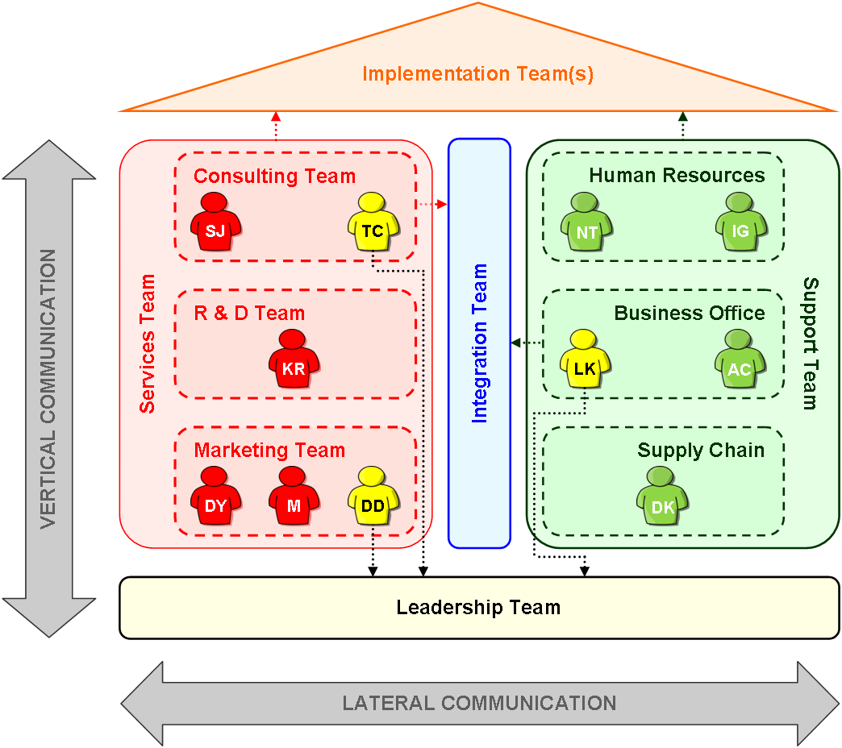
Figure 1: Organization Structure of Garrison Business Systems, LLC.

The Services Team consists of a Consulting Sub-Team, a Research and Development Sub-Team, and a Marketing Sub-Team. The Marketing Sub-Team’s main focus is advertising, branding, customer identification, and first contact with customers. As Garrison’s customer value delivery is primarily knowledge work, the Research and Development Sub-Team is charged with keeping the “stock” of knowledge needed to deliver value to customers relevant and up-to-date. The Consulting Sub-Team functions as both subject matter expert in the area of disaster recovery/business continuity, and also as project management for customer projects. Individual sub-team charters are provided below.
The Support Team consists of a Human Resources Sub-Team, a Business Office Sub-Team, and a Supply Chain Sub-Team. The Human Resources Sub-Team manages employees as a resource to support customer value delivery, including recruitment, HRIS, benefits, employee relations, coaching & professional development, employee performance management. The Business Office Sub-Team focuses on contract management and company finances. The Supply Chain Sub-Team contributes sourcing, procurement, and supplier relationship management to facilitate the delivery of value and quality services to the company’s customers. All Support Team members also serve on customer projects as needed. Individual sub-team charters are provided below.

The Integration Team consists of members of the Services Team and the Support Team. The primary purpose of the Integration Team is to identify cross-team needs, as well as to facilitate lateral communication and coordination, between the Services Team and the Support Team to support the Implementation Team in delivering value to the Garrison’s customers. As the Implementation Team identifies customer project resource needs, the Integration Team communicates those needs to the Services Team and the Support Team. The Human Resources Sub-Team identifies available employee resources, and works with the Integration Team to make those project resource assignments. At the same time, gaps in needed resources are filled by the Supply Chain Sub-Team via purchased contract services.

The Implementation Team also consists of members of the Services Team and the Support Team. The primary purpose of the Implementation Team is to directly deliver services to Garrison’s customers. Resources for customer project implementations are managed through the Integration Team as described above.

Finally, the Leadership Team also consists of members of the Services Team and the Support Team. The Leadership Team is accountable to capital providers and/or shareholders for the company’s performance, establishes the company’s overall direction, aligns the various teams of the company with that overall direction, and provides an escalation path for inter-team issues that cannot be resolved at the team level. Members of the Leadership Team are comprised of one member of the Consulting Sub-Team, one member of the Marketing Sub-Team, and one member of the Business Office Sub-Team. The members of the Services Team select the two members to represent them on the Leadership Team, and the members of the Support Team select the member to represent them on the Leadership Team.

Team Charters

Implementation Team Charter
Implementation Team Charter
1 BROAD ORGANIZATION GOALS
- Year One
- Identify client base
- Breakeven (about 12 customer projects)
- 85% on-time delivery of services
- Obtain source of capital
- Acquire supplier base
- Years Two Through Five
- Increase on-time delivery of services by 2% per year
- Achieve no less than an average of 4.5 points out of 5 points for customer satisfaction rating
- Identify at least one new market/service for expansion of service offerings
- Diversify client base
- Achieve 10% profitability by Year Five
- Increase the ratio of in-house personnel to all personnel offering customer services

2 MISSION OF TEAM
The mission of the Implementation Team is to deliver services to customers, including:
- Audit/analysis
- Certifications
- Complete/create new plan
- Drills, practice, training

3 BUSINESS UNIT GOALS
- 85% on-time delivery of services in Year One
- Increase on-time delivery of services in Years Two through Five by 2% per year
- Achieve no less than an average of 4.5 points out of 5 points for customer satisfaction rating

4 STAKEHOLDERS AND THEIR KEY SPECTATIONS
Customers:
- Easy to understand contracts
- On time complete of contracted services
- Service-oriented back office functions (e.g., billing, collections, etc.)
Internal teams:
- Clear project management elements (e.g., tasks, performance metrics, results, milestones, etc.)
- (through integration team) - resource needs, sub-team member selection process, sub-team member repatriation process, marketing research, market research/needs
Suppliers:
- Clear project management elements (e.g., tasks, performance metrics, results, milestones, etc.)

Implementation Team Charter (cont.)
5 RESOURCES
People:
- Assigned as needed upon consulting project(s) and will be specified by integration team:
- Project manager
- Reviewer
- Specialist(s)
- Note: Typical project will have a base of 2.5 to 3 full-time equivalents (FTEs)
Budget:
- People as noted above.
- Purchased services (e.g., legal, IT)

6 ESCALATION PATH
- Issues that can’t be resolved will be escalated to the leadership team
- Customer complaints, comments, concerns will be funneled to the Integration Team => any unresolved situations will be escalated to Leadership Team

7 REQUIREMENTS FOR INTEGRATION WITH OTHER GROUPS
- Lateral communication through Integration Team

8 REVIEW PROCESSES
- Project milestones
- Customer satisfaction regarding project performance
- Upon project completion report project performance metrics to Leadership Team

Consulting Sub-Team Charter
Consulting Sub-Team Charter
1 BROAD ORGANIZATION GOALS
- Year One
- Identify client base
- Breakeven (about 12 customer projects)
- 85% on-time delivery of services
- Obtain source of capital
- Acquire supplier base
- Years Two Through Five
- Increase on-time delivery of services by 2% per year
- Achieve no less than an average of 4.5 points out of 5 points for customer satisfaction rating
- Identify at least one new market/service for expansion of service offerings
- Diversify client base
- Achieve 10% profitability by Year Five
- Increase the ratio of in-house personnel to all personnel offering customer services

2 MISSION OF TEAM
To provide consulting services to the company, its teams, and its sub-teams, to assure that the company can: (1) deliver the required value to its customers; and (2) meet its broad organization goals.
To accomplish its mission, the Consulting Sub-Team will:
- Identify client requirement
- Build internal/external implementation team
- On-site assessment
- Address internal improvements
- Create own recovery plans and documents
The secondary mission of the Consulting Sub-Team is to develop the capabilities/capacity for delivering services to customers through:
- Internal capabilities assessment
- Implementation of internal improvements
- Creation of Garrison Business Systems, LLC’s own recovery plans and documents

3 TEAM GOALS
- Achieve 4.5/5 on customer satisfaction survey. To be developed, based upon accuracy and simplicity of plan working upon tragedy.

Consulting Sub-Team Charter (cont.)
4 STAKEHOLDERS AND THEIR KEY EXPECTACTIONS
Customers:
- Direct communication to determine services needed
- On time complete of contracted services
- Contracted services meet the customers’ needs
- Service-oriented project strategy development and project kick-off
Internal teams:
- Clear project management elements (e.g., tasks, performance metrics, results, milestones,
etc.)
- (through Integration Team) - resource needs, sub-team member selection process, sub-team member repatriation process, marketing research, market research/needs
- (through Leadership Team) – report completion of jobs and client satisfaction of services
Suppliers:
- Clear project management elements (e.g., tasks, performance metrics, results, milestones, etc.)

5 RESOURCES
People:
- 100% of time of two project managers/consultants (Sara and TJ)
- Travel as needed to visit clients and determine need
- 50% of time of one administrative assistant.
- Outsourced professionals, as needed
Budget:
- People as noted above.
- Travel as required up to 75% travel annually for two project managers/consultants.
- Work stations and software.

6 ESCALATION PATH
- Unresolved issues between Consulting Team and other Support Team sub-teams are escalated to Support Team Leader
- Unresolved issues between Consulting Team and Implementation Team are escalated to Integration Team
- Unresolved issues between Consulting Team and Services and Integration Teams are escalated to Leadership Team
Consulting Sub-Team Charter (cont.)
7 REQUIREMENTS FOR INTEGRATION WITH OTHER GROUPS
- Consulting Team will work directly with Integration Team to build a consulting team
appropriate for task as needed.
- Use appropriate measures to evaluate and fine tune other sub-charter processes.
- Monthly luncheon meetings with Marketing and R&D Charters to integrate and align goals, discuss information to pass along to Leadership Team.

8 REVIEW PROCESSES
- Completion of jobs and client satisfaction of services reported to Leadership Team

Research & Development Sub-Team Charter
Research & Development Sub-Team Charter
1 BROAD ORGANIZATION GOALS
- Year One
- Identify client base
- Breakeven (about 12 customer projects)
- 85% on-time delivery of services
- Obtain source of capital
- Acquire supplier base
- Years Two Through Five
- Increase on-time delivery of services by 2% per year
- Achieve no less than an average of 4.5 points out of 5 points for customer satisfaction rating
- Identify at least one new market/service for expansion of service offerings
- Diversify client base
- Achieve 10% profitability by Year Five
- Increase the ratio of in-house personnel to all personnel offering customer services
2 MISSION OF TEAM
The Research and Development team will assist in creating innovative products, utilize
cost-efficient methods, and guide Garrison toward becoming the most cutting edge disaster planning service in the market.

To accomplish its mission, the R & D Sub-Team will:
- Work closely with the marketing team to gather data and implement changes to the product/services.
- Attend expos and conventions to stay ahead of the curve.
- Strive to continuously monitor and improve upon services.
- Anticipate market changes/expansion.
- Keep up with federal regulations on our product, and implement changes in process flow as necessary.

3 TEAM GOALS
- Attend a minimum of one trade show per month.
- Create a process flow between R & D and marketing departments.
- Evaluate service offerings yearly compared to the market.
- Improve growth ratio by 5%.

4 STAKEHOLDERS AND THEIR KEY EXPECTACTIONS
The Research and Development Department is responsible for product innovation and performance evaluation, which includes the following:
Research for and development of new products:
- Attending trade shows.
- Conducting customer satisfaction data gathering.

Research & Development Sub-Team Charter (cont.)
4 STAKEHOLDERS AND THEIR KEY EXPECTACTIONS (cont.)
Product maintenance and enhancement:
- Maintain existing products/documents.
- Identify new components for improvement.
Quality and regulatory compliance:
- Implementing federal standards/regulations of product quality.

5 RESOURCES
People
- 15% of one marketing personnel.
- 100% one consultant.

Budget
- 1-4 trips per month.

6 ESCALATION PATH
- Unresolved issues between R & D and other Support Team sub-teams are escalated to Support and Service Team Leaders.
- Unresolved issues between R & D and Implementation Team are escalated to Integration Team.
- Unresolved issues between R & D and Services, Support, and Integration Teams are escalated to Leadership Team.

7 REQUIREMENTS FOR INTEGRATION WITH OTHER GROUPS
- R & D will work closely with Marketing to develop ideas on new products/customers.
- R & D works with the whole Services team to ensure Garrison is functioning efficiently.
- R & D reports to the Leadership and Integration team in their scheduled time frames.

8 REVIEW PROCESSES
- Budget is reviewed monthly by Finance department.
- Quarterly review of projects and deadlines.
- Yearly evaluation of expo schedule.

Marketing Sub-Team Charter
Marketing Sub-Team Charter
1 BROAD ORGANIZATION GOALS
- Year One
- Identify client base
- Breakeven (about 12 customer projects)
- 85% on-time delivery of services
- Obtain source of capital
- Acquire supplier base
- Years Two Through Five
- Increase on-time delivery of services by 2% per year
- Achieve no less than an average of 4.5 points out of 5 points for customer satisfaction rating
- Identify at least one new market/service for expansion of service offerings
- Diversify client base
- Achieve 10% profitability by Year Five
- Increase the ratio of in-house personnel to all personnel offering customer services

2 MISSION OF TEAM
The Marketing team will provide results-oriented advertising, client identification, new business consulting, and public relations. Our marketing will be designed to meet our company’s objectives by providing strong marketing concepts and excelling at customer service.

To accomplish this mission, the Marketing Sub-Team will:
- Define a customer base
- Companies located in Michigan
- Human and public sectors
- Government or government type industries
- Small to medium sized companies
- Organizations with grant funding

3 TEAM GOALS
- Identify ten new clients each month
- Contract a minimum of one
- Create a process flow between R&D and Marketing
- Research emergency preparedness laws
- Attend trade shows to get our name out to the public
Marketing Sub-Team Charter (cont.)
4 STAKEHOLDERS AND THEIR KEY EXPECTATIONS
The Marketing team is responsible for brand awareness, client identification, new business
consulting, publications, budget requests, and public relations.
- Customers and employees will look to the marketing team to provide each of these
responsibilities.

5 RESOURCES
People:
- Three Marketing Team members
Budget:
- People as noted above
- Work stations, supplies, travel

6 ESCALATION PATH
- Unresolved issues between the Marketing Sub-Team and other Service Team sub-teams are escalated to the Service and Support Team Leaders
- Unresolved issues between the Marketing Sub-Team and the Implementation Team are escalated to the Integration Team.
- Unresolved issues between the Marketing Sub-Team and the Support Team and Integration Team are escalated to the Leadership Team.

7 REQUIREMENTS FOR INTEGRATION WITH OTHER GROUPS
- Marketing will work closely with R&D to advertise new ideas and products/customers.
- Marketing will work closely with the entire Service Team to allow efficient use of marketing techniques and strategies in order to gain new clients.
- Marketing reports to the Leadership Team and Integration team in their scheduled time frames.

8 REVIEW PROCESSES
- Budget is reviewed monthly by Finance Department
- Quarterly review of projects and deadlines

Human Resources Sub-Team Charter
Human Resources Sub-Team Charter
1 BROAD ORGANIZATION GOALS
- Year One
- Identify client base
- Breakeven (about 12 customer projects)
- 85% on-time delivery of services
- Obtain source of capital
- Acquire supplier base
- Years Two Through Five
- Increase on-time delivery of services by 2% per year
- Achieve no less than an average of 4.5 points out of 5 points for customer satisfaction rating
- Identify at least one new market/service for expansion of service offerings
- Diversify client base
- Achieve 10% profitability by Year Five
- Increase the ratio of in-house personnel to all personnel offering customer services

2 MISSION OF TEAM
The mission of the Human Resources Department is to look out for the employee’s best interest, as they are Garrison’s most valuable asset, and without them our company would come to a screeching halt. For this reason the Human Resources Department is dedicated to ensuring that we both value and protect this asset. Our office realizes that each employee represents a million dollar investment on behalf of the company and when making decisions that involve our workforce we will treat it as such.

In connection with the mission and the vision of Garrison the human resource department will find, secure, guide, and develop employees whose talents and desires are compatible with the operating needs and future goals of the company.

3 TEAM GOALS
The Hiring Process:
Human Resources will be charged with upholding Garrison’s Mission by ascertaining that the candidate is both qualified and ethical, along with vowing that we will also hire for passion and attitude.
Benefits Management:
Human Resources, with input from the all employees, will establish and maintain a benefits package that is both fair to the employee, and fiscally responsible for the employer.

Human Resources Sub-Team Charter (cont.)
4 STAKEHOLDERS AND THEIR KEY EXPECTATIONS
Employees:
- Annual Performance Review:
- Human Resources will insure that each employee is involved in an annual 360°
Performance Review, which will focus on both their strengths and define training opportunities so that the employee is able to advance their skills and abilities.
- Employee Engagement:
- Human Resources will assist in the creation of an environment where employees are recognized for their efforts, and contributions. We will accomplish this by providing praise, coaching, and professional development opportunities. Human Resources will monitor each employees work life balance to safeguard the employee against burnout.
- Motivate Employees:
- Human Resources will remove barriers to productivity. This will be accomplished by tracking each employee’s productivity. As Human Resources professionals, we will be highly trained in handling conflicts and bureaucracy.

5 RESOURCES
People:
- 2 full time employees
Budget:
- People as noted above
- Two Professional Memberships in SHRMA

6 ESCALATION PATH
- Unresolved issues are escalated to the leadership team.

7 REQUIREMENTS FOR INTEGRATION WITH OTHER GROUPS
- Members coordinate the integration of other teams that form and work closely with those teams to monitor their cohesiveness.
- The Human Resource department responsibilities at Garrison will be subdivided into three areas: individual, organizational, and career.

Human Resources Sub-Team Charter (cont.)
8 REVIEW PROCESSES
- Individual management entails helping employees identify their strengths and weaknesses;
correct their shortcomings; and make their best contribution to the enterprise.
- Organizational development focuses on fostering a successful system that maximizes
human resources and other departments as part of larger business strategies. This important duty also includes the creation and maintenance of a change program, which allows the organization to respond to evolving outside and internal influences.
- Career development will match individuals with the most suitable jobs and career paths within the organization.

Business Office Sub-Team Charter
Business Office Sub-Team Charter
1 BROAD ORGANIZATION GOALS
- Year One
- Identify client base
- Breakeven (about 12 customer projects)
- 85% on-time delivery of services
- Obtain source of capital
- Acquire supplier base
- Years Two Through Five
- Increase on-time delivery of services by 2% per year
- Achieve no less than an average of 4.5 points out of 5 points for customer satisfaction rating
- Identify at least one new market/service for expansion of service offerings
- Diversify client base
- Achieve 10% profitability by Year Five
- Increase the ratio of in-house personnel to all personnel offering customer services

2 MISSION OF TEAM
The Finance Department is committed to providing timely, accurate, clear and complete information and support to other sub teams as well as the organization as a whole.
To accomplish its mission, the Finance Sub-Team will:
- Provide the highest level of ethical standards. The services and decisions we offer will be honest, fair, and impartial.
- Offer guidance and support to all sub-teams with any budgetary inquiries
- Monitor budgets on a monthly basis and bring up concerns in a timely manner (as they arise).
- Leads by example while encouraging growth and continued learning.
- Supports collective decision making in the best interest of our customers, the organization at large and its members.
- ● Maintain required regulatory documentation.
3 TEAM GOALS
- Ensure yearly expenses do not exceed budget by more than 5%
- Provide timely financial data to facilitate proper administration.
- Ensure complete and accurate accounting of all transactions.
- Report all financial information in accordance with professional accounting standards and federal, state, and local laws.
Business Office Sub-Team Charter (cont.)
4 MAJOR FUNCTIONS AND ACTIVITIES
The Finance Department is responsible for managing the company’s financial matters which
include the following:
Accounting, GL, Bank Reconciliation:
- Administers the general ledger, maintains accounts receivable, and controls reimbursements and interdepartmental billings.
- Balancing utility receivables, providing property control, and producing numerous other financial reports as requested.
Accounts Receivable/Billing:
- Accounts for and coordinates the collection of receivables that are due to the company, including timely recovery of dishonored checks.
- 60% of estimated price up front
- 20% within 30 days of project initiation
- 20% + additional expenses at culmination of project
- $75 fee on returned checks with 48-72 business hours to take care of to avoid suspension of project
Asset Management:
- Responsible for recording, reporting, tracking, and retiring capital items.
Accounts Payable/Payroll:
- Payroll: 15th and 30th each month
- Accounts Payable: Cut checks weekly
Budgeting:
- Yearly budget
- Monitor monthly (during reconciliation process)
- Concerns brought up as needed

5 RESOURCES
People
- 75% of time of one finance manager.
- 100% of time of one administrative assistant.

Budget
- People as noted above.
- Work stations, supplies and software.

Business Office Sub-Team Charter (cont.)
6 ESCALATION PATH
- Unresolved issues between Finance Sub-Team and other Support Team sub-teams are
escalated to Support and Service Team Leaders.
- Unresolved issues between Finance Sub-Team and Implementation Team are escalated
to Integration Team.
- Unresolved issues between Finance Sub-Team and Services and Integration Teams are escalated to Leadership Team.

7 REQUIREMENTS FOR INTEGRATION WITH OTHER GROUPS
- Finance Sub-Team sets up budgets for the company in coordination with Leadership Team in accordance to sub-team’s and available/feasible monetary amounts.
- Finance Sub-Team supports and participates in Implementation Team lessons learned reviews.

8 REVIEW PROCESSES
- Budget is reviewed monthly for each sub-team
- Financial service performance for Support, Service, and Integration Teams reviewed
monthly during P & L review.
- Budget/financial status is communicated to all members of company quarterly.

Supply Chain Sub-Team Charter
Supply Chain Sub-Team Charter
1 BROAD ORGANIZATION GOALS
- Year One
- Identify client base
- Breakeven (about 12 customer projects)
- 85% on-time delivery of services
- Obtain source of capital
- Acquire supplier base
- Years Two Through Five
- Increase on-time delivery of services by 2% per year
- Achieve no less than an average of 4.5 points out of 5 points for customer satisfaction rating
- Identify at least one new market/service for expansion of service offerings
- Diversify client base
- Achieve 10% profitability by Year Five
- Increase the ratio of in-house personnel to all personnel offering customer services

2 MISSION OF TEAM
To provide supply chain services to the company, its teams, and its sub-teams, to assure that the company can: (1) deliver the required value to its customers; and (2) meet its broad organization goals.
To accomplish its mission, the Supply Chain Sub-Team will:
- Provide guidance and support for all purchasing decisions that minimize costs while optimizing quality and services.
- Build, maintain, and improve the company’s bank of suppliers and contractors and their service agreements to enable the company to fulfill its mission and minimize the amount of time work is in progress.
- Participate in and support demand planning.
- Respond to and resolve company and supplier grievances in a timely manner.
- Ensure business resilient practices for critical services.
- Maintain required regulatory documentation.

3 TEAM GOALS
- Achieve fill rate of suppliers/service providers of 100%.
- Achieve on time performance of suppliers/service providers of 100%.
- Achieve upside flexibility of suppliers/service providers to be as needed up to 25%.
- Maintain an annual purchased services budget of $300,000 or less.

4 STAKEHOLDERS AND THEIR KEY EXPECTACTIONS
Customers
- Support of integration and customer project teams to achieve value delivery to customer.
Supply Chain Sub-Team Charter (cont.)
4 STAKEHOLDERS AND THEIR KEY EXPECTACTIONS (cont.)
Leadership Team:
- Up-to-date supplier performance data.
- Negotiate with suppliers for best pricing and value.
- Timely notification of problems and overruns.
Implementation Team:
- Monitors suppler performance during customer projects.
- Timely sourcing of materials and services not previously demanded or anticipated.
- Liaise between implementation team and supplier base.
- Contributes to and participates in lessons learned reviews.
Integration Team:
- Maintenance of supplier base to fill internal resource gaps for projects.
- Timely sourcing of materials and services not previously demanded or anticipated.
- Liaise between integration team and supplier base.
Services and Support Teams:
- Timely sourcing of materials and services required.
- Liaise between teams and supplier base.
Suppliers:
- Liaise between teams and supplier base.

5 RESOURCES
People:
- 100% of time of one supply chain manager.
- 15% of time of one administrative assistant.
Budget:
- People as noted above.
- Travel as required up to 15% travel annually for supply chain manager.
- Work stations and software.

6 ESCALATION PATH
- Unresolved issues between Supply Chain Sub-Team and other Support Team sub-teams are escalated to Support Team Leader.
- Unresolved issues between Supply Chain Sub-Team and Implementation Team are escalated to Integration Team.
- Unresolved issues between Supply Chain Sub-Team and Services and Integration Teams are escalated to Leadership Team.

Supply Chain Sub-Team Charter (cont.)

7 REQUIREMENTS FOR INTEGRATION WITH OTHER GROUPS
- Supply Chain Sub-Team coordinates purchased materials and services directly with
various other teams of the company (i.e., Support, Service, Integration and Implementation
Teams).
- Supply Chain Sub-Team provides KPI (Key Performance Indicator) data to Leadership Team
monthly.
- Supply Chain Sub-Team supports and participates in Implementation Team lessons learned reviews.

8 REVIEW PROCESSES
- Purchased service performance for Implementation Team reviewed at each project milestone.
- Purchased service performance for Support, Service, and Integration Teams reviewed monthly during P & L review.
- Purchased service performance communicated to all members of company quarterly.

Integration Team Charter
Integration-Team Charter
1 BROAD ORGANIZATION GOALS
- Year One
- Identify client base
- Breakeven (about 12 customer projects)
- 85% on-time delivery of services
- Obtain source of capital
- Acquire supplier base
- Years Two Through Five
- Increase on-time delivery of services by 2% per year
- Achieve no less than an average of 4.5 points out of 5 points for customer satisfaction rating
- Identify at least one new market/service for expansion of service offerings
- Diversify client base
- Achieve 10% profitability by Year Five
- Increase the ratio of in-house personnel to all personnel offering customer services

2 MISSION OF TEAM
The mission of the Integration Team is to integrate our products and services to meet our client’s needs.

3 TEAM GOALS
- Provide clear and concise communication throughout the entire team.
- Pursue customer feedback on completed projects.
- Disseminate information to sub teams to improve processes.
- Maintain supplier base to fill internal resource gaps for projects.

4 STAKEHOLDERS AND THEIR KEY EXPECTACTIONS
- Support of Customer project teams and personnel teams to achieve value delivery to customer processes.
- Maintain supplier base to fill internal resource gaps for projects.

5 RESOURCES
People:
- Leadership Team, plus Nicole Thomsen and Daniel Yatzek
Budget:
- Stakeholders view this team as an additional responsibility.

6 ESCALATION PATH
- Unresolved issues will escalate to Leadership Team.

Integration-Team Charter (cont.)
7 REQUIREMENTS FOR INTEGRATION WITH OTHER GROUPS
- Coordination of a cohesive team with a seamless transition between workgroups and
sub teams.

8 REVIEW PROCESSES
- Feedback will be received from customer through Daniel Yatzek's follow up.
- Feedback will be received from employees via the thoughts dreams and aspirations box.

Leadership Team Charter
Leadership-Team Charter
1 BROAD ORGANIZATION GOALS
- Year One
- Identify client base
- Breakeven (about 12 customer projects)
- 85% on-time delivery of services
- Obtain source of capital
- Acquire supplier base
- Years Two Through Five
- Increase on-time delivery of services by 2% per year
- Achieve no less than an average of 4.5 points out of 5 points for customer satisfaction rating
- Identify at least one new market/service for expansion of service offerings
- Diversify client base
- Achieve 10% profitability by Year Five
- Increase the ratio of in-house personnel to all personnel offering customer services

2 MISSION OF TEAM
The Leadership Team will develop the skill sets of the team along with the company as a whole.

3 TEAM GOALS
To provide clear direction in preparation for a successful organization. Mentor Junior Leaders to assume the mantle of the leadership team.

4 STAKEHOLDERS AND THEIR KEY EXPECTACTIONS
Customers and employees who are looking to the leadership team to provide stability and direction, as well as they development of their professional ambitions.

5 RESOURCES
People:
- The Leadership team will be comprised of elected individuals from:
- One (1) individual from the Consulting Sub-Team.
- One (1) individual from Marketing/R&D Sub-Teams.
- One (1) individual from the Support Sub-Team.
- The leadership team and junior leaders will be voted by majority vote bi-annually each November and with Junior shadowing the seasoned team from November to January.
Budget:
- Impact will be an additional $10,000 stipend annually.

Leadership-Team Charter (cont.)
6 ESCALATION PATH
If consensus cannot be reached the integration team will step in for a majority rules vote.

7 REQUIREMENTS FOR INTEGRATION WITH OTHER GROUPS
Disseminate information to the integration, implementation, service, and support teams.

8 REVIEW PROCESSES
This will be done via the election and impeachment process.

Marketing Plan

Market Research

Statistics Regarding Disaster Recovery/Business Continuity Planning
According to Gulf Coast Back to Business Act of 2007, the US Congress found that:
- 43% of businesses that close following a natural disaster never reopen; and
- An additional 29% of businesses close down permanently within 2 years of a natural disaster.
According to the Symantec 2011 SMB Disaster Preparedness Survey:
- 57% percent of small businesses do not have a disaster recovery/business continuity plan.
- 47% percent of medium businesses do not have a disaster recovery/business continuity plan.
- 65% of small and medium businesses reside in regions that they consider susceptible to natural disasters.
- When asked why no disaster recovery/business continuity plan, the reasons given were:
- 52% did not view computer systems as critical to the business;
- 41% responded that it never occurred to them to put together a plan; and
- 40% stated that disaster preparedness is not a priority.

Legal/Compliance Environment
The legal/compliance aspect of disaster recovery/business continuity planning is highly complex. Having a good disaster recovery/business continuity plan can help a company maximize federal relief money, for example, under The Disaster Mitigation Act of 2000 (United States Public Law 106-390). Federal, state, regional, and local governments are mandated to emergency management plans. One trickle down effect is that often even private suppliers of contracted services deemed critical must have a disaster recovery/business continuity plan in place to keep their contracts. Mandates disaster recovery/business continuity plans are also imposed on certain industries considered to be critical to the public infrastructure, such as banks, financial institutions, electric utilities, and healthcare providers. A recent US Department of Labor interpretation of the Occupational Safety and Health Act of 1970 may eventually encourage or require employers with ten or more employees to have an emergency preparedness plan. The list could go on and on, but for the sake of brevity, the multitude of laws and regulations permitting electronic storage of personal and financial data are also balanced by laws requiring reliable and robust protection of that data and critical services, even in times of emergency.

Private Standards Environment
Disaster recovery/business continuity plans may also be required as part of conformance to private standards, such as International Standards Organization (ISO) 9000 or 27001, or Statement on Auditing Standard (SAS) 70. Conformance to such standards is usually market-driven rather than regulatory in nature.

Business Strategy
Garrison intends to pursue a client base with the following attributes:
- Geographic: Michigan
- Sector: Government and Non Profit
- Industry: Human/Public Services
- Size: Small to Medium Organizations
- Source of Funding: Grant Funded or Grant Awarded Organizations

Garrison intends to pursue professional relationships with grant awarding agencies and organizations which may assist in identifying potential customers fitting the above profile. Garrison will also participate in trade and business organizations which may also highlight potential customers who have been awarded or are seeking grants for the development of disaster recovery/business continuity plans. Some special market niches from the above potential client base profile that Garrison will actively monitor for opportunities are small to medium municipal agencies (especially those which are part of the Homeland Security network), lower-tier government contractors, minority owned businesses, women owned businesses, and Native American tribal owned businesses.

Operational Plan

Legal Entity and Ownership
Garrison Business Systems, LLC, is a privately held limited liability corporation incorporated in the State of Delaware. The company, a C corporation, is jointly owned by the following shareholders: Angie Carreon, Thomas Clark, Dennis DeSmet, Idella Green, Sara Jacobs, David Kallsen, Lori Kosarue, Michael McGee, Katelyn Revill, Nicole Thomsen, and Daniel Yatzek.

Premises
113 W. Front St.  Adrian, MI 49221  Commercial office space for lease. Remodeled office  building has 4,100 square feet available, with large  windows, main floor entry, on site parking lot. Both first  and lower level available, with elevator to lower level. | 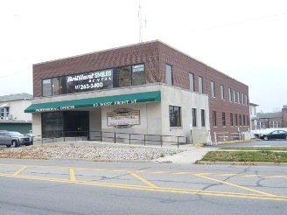
Handicap accessible.

Choice of Location and Premises
The premises is conveniently located near the homes of most employees, as well as conveniently located near several metropolitan areas, including Detroit, Michigan, and Toledo, OH. The Adrian, Michigan, area affords a lower cost of living and cost of doing business, and has a well developed infrastructure, including a major healthcare alliance, an economic development corporation, and three area colleges/universities.

Hours of Operation
The posted hours of operation are Monday through Friday, 8 a.m. through 5 p.m. It is anticipated, however, that the staff of Garrison Business Systems, LLC, will as needed travel and work times outside of posted hours of operation.

Equipment
Garrison will require an initial capital investment in office furniture and supplies. These will include: Desks/cubicles, desk chairs, all in one printer (purchased or leased), printer toner, printer service agreement, computers, laptops, filing cabinets, telephone system (including a conference phone for the conference room), and conference room table and chairs. Garrison will also require typical offices supplies, including but not limited to: Paper, pens, binders, staplers, staples, staple removers, paper clips, hole punch, lamps, envelopes, note pads, highlighters, tape, dry eraser board, and dry erase markers, erasers, and cleaners.

Staffing
Garrison has eleven full time employees who are also the eleven shareholders of the corporation. Desiring to manage the company’s growth and be a responsible employer, Garrison will fill skill set gaps through contracted services in Year One. In Years Two through Five, Garrision will seek to expand its staff to reduce reliance on contracted services and better support business operations and customer projects with in-house skill sets.

Contracted Services
Several gaps in needed skill sets have been identified between the current skill sets of Garrison employees and what is needed to support Garrison’s business operations and customer projects. These needed skill sets are:
- legal/paralegal
- IT/technology services
- Project assistant/coordinator/admin assistant
Garrison has opted to initially contract these skill sets, but will eventually strive to develop in-house capability in these areas.

Capacity
In Year One, Garrison plans to complete a minimum of twelve customer projects. As initial knowledge bank is built and organized, and business and project processes are refined, our goal is to increase the number of projects by a minimum of two projects per year from Years Two through Five to support the broad organizational goal of achieving 10% profitability by Year Five.

Business License
A business license will be required for the State of Delaware, Garrison’s state of incorporation. An annual renewal of that business license will be required. Also, a Foreign Corporation Fee will be due the State of Michigan annually.

Business Insurance
Garrison will maintain the following insurances:
- Renters insurance for replacement value of contents – at $750,000 (Hiscox Quote #395635)
- Vehicle insurance to protect the company’s interests in the event an employee is involved in a vehicular accident while traveling on company business;
- General liability insurance - $600,000 per occurrence: $1,200,000 annually (Hiscox Quote #395635)
- Workers compensation; and
- Unemployment insurance

Financial Plan

Annual Operating Budget
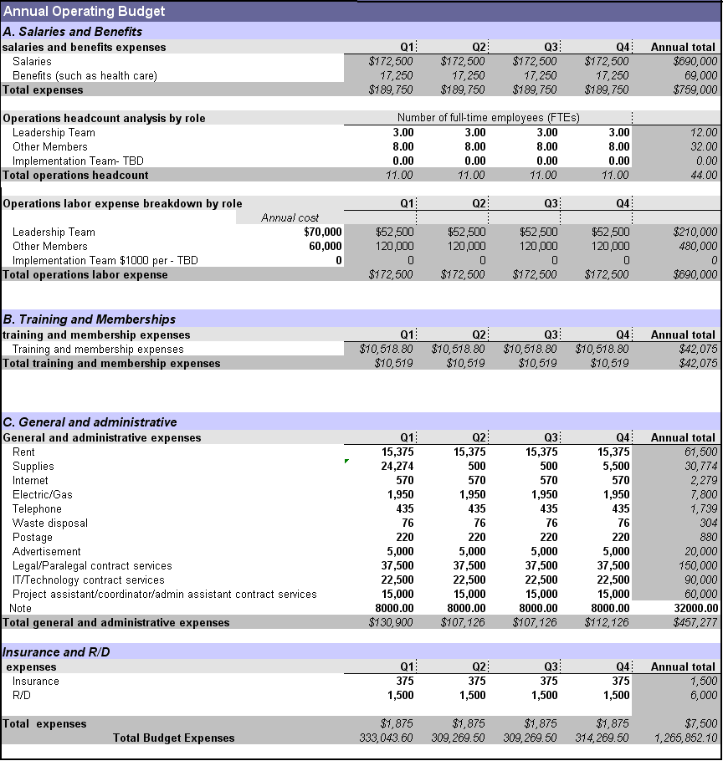

Annual Income Statement
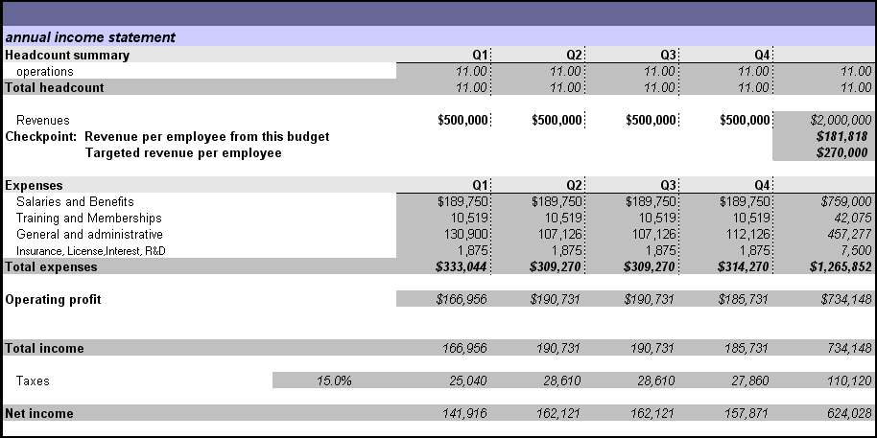

Accounting System
Garrison’s accounts systems and processes are compliant with Generally Accepted Accounting Principles (GAAP) and all applicable laws, regulations, and Security and Exchange Commission’s rules regarding United States publicly traded companies. Garrison is Sarbanes Oxley 302 and 404 compliant. Please refer to Garrision’s annual report for certification by company officers and external auditing firm.

Appendices

Appendix A: Meet the Leadership Team!

Thomas “TJ”Clark
TJ is the senior member of Garrison’s Consulting Sub-Team. A US Army veteran who earned the rank of Sergeant Major while concurrently working as a firefighter and paramedic for the City of Livonia Fire and Rescue, TJ also serves as the Emergency Management Coordinator and Homeland Security Director for Shiawassee County, Michigan. He earned his Bachelor of Applied Science Degree in Public Safety Administration from Siena Heights University in 2011, and currently pursuing his Masters Degree in Homeland Security Leadership at Siena Heights University.

Dennis DeSmet
Dennis is the senior member of Garrison’s Marketing Sub-Team. He earned his Bachelor of Science in Biology/Environmental Science from Adrian College, and is currently pursuing his Masters Degree in Leadership at Siena Heights University. Dennis also an Admissions Counselor at Adrian College.

Lori Kosarue
Lori is the senior member of Garrison’s Business Office Sub-Team. She contributes a wealth of knowledge in the area of Finance, and most recently worked at Siena Heights University as a Financial Aid Officer. Like TJ and Dennis, Lori is pursuing her Masters Degree in Leadership at Siena Heights University

